



HOW TO GUIDE:
SET UP NEW DOMAIN

SET UP A NEW ORGANAZATION:

- Log in to the “Hosting Controller Portal”

- Click on “Provisioning” – “Exchange”:

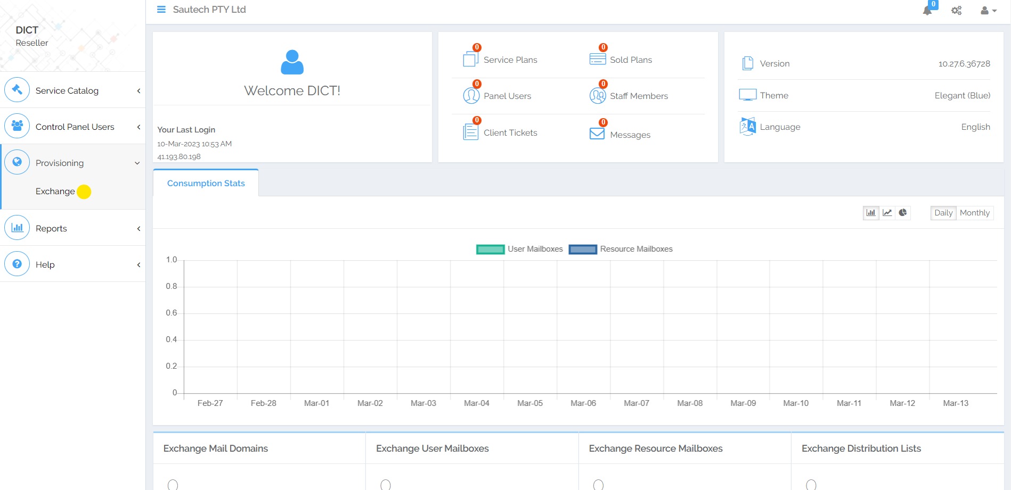

- Create Organization (add Domain):

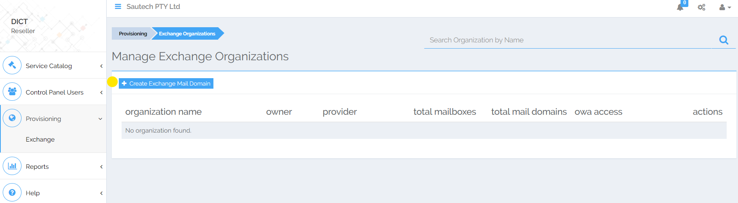

Complete the following Information:
- Organization Name
- Mailbox Database (Choose Namibia)
- Mail Domain Name
- Click on “Create Exchange Mail Domain”:

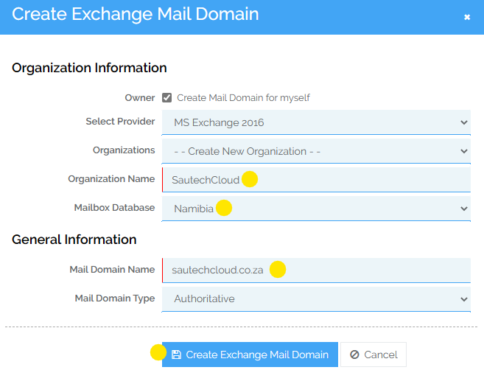

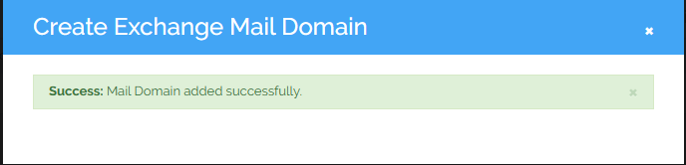

- Once the Domain is added, click on “Mailboxes”:

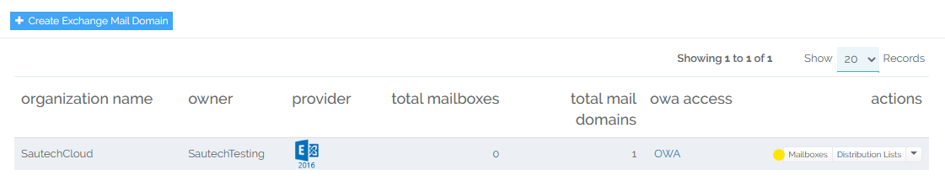

- Create Mailbox:

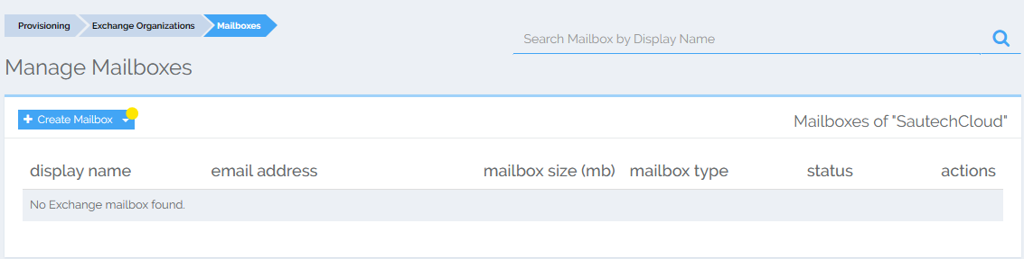

Complete the following Information:
- Mailbox Name
- Password
- Confirm Password (Passwords must match)
- Mailbox Size (MB)
- Prohibit Sent at (MB)
- Issue Warning at (MB)

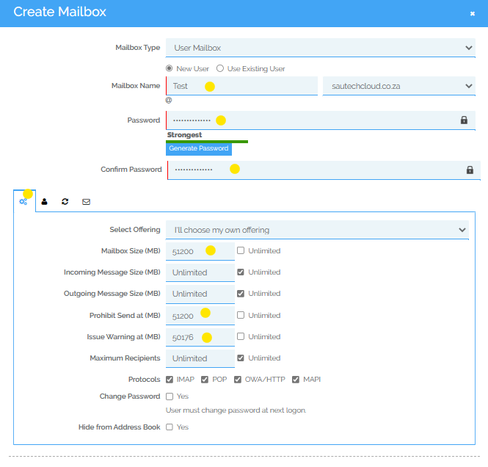

- Click on “User Profile”:

Complete the following Information:
- Name
- Display Name
- Click on Create Mailbox:
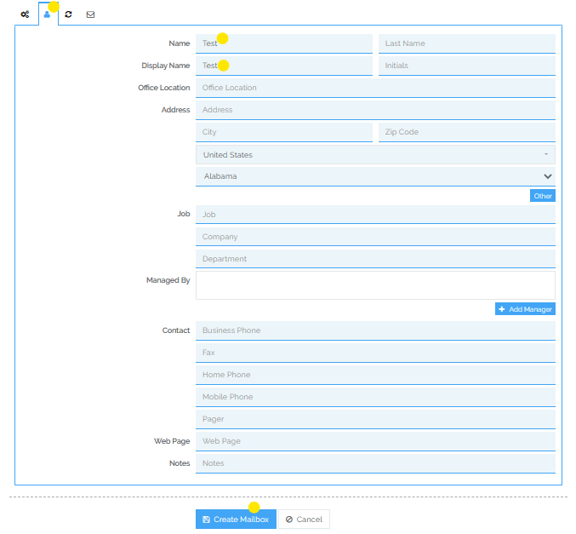

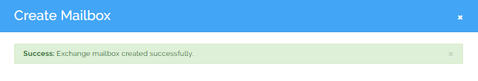
- Log in to “Spam Titan”:

- Click on System Set Up
- Click on Mail Relay
- Click on Domains
- Add:
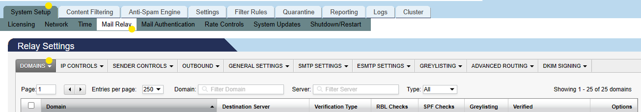

Complete the following Information:
- Domain
- Destination Server
- Click on “Save”

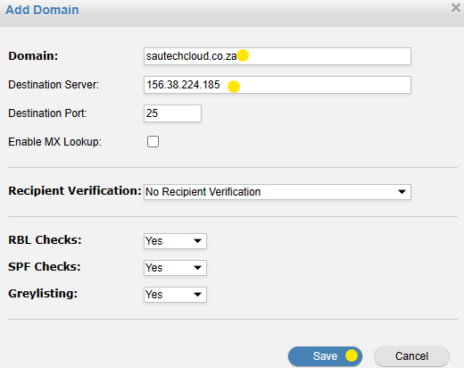

- DNS Records to be added on Domain:

Name Type TTL Value
@ MX 1800 10 gimli.onlinehosting.co.za
Autodiscover A 1800 156.38.224.186
_autodiscover._tcp SRV 1800 0 0 443 autodiscover.sautechcloud.co.za

*MX record TBC*

- Once the DNS Records have been added:

- Send Sautech an email with the Domain Name to add on to IIS on the Exchange Server.

